STAT 112 - Introduction to Data Processing and Visualization Project
Guide For Fashion Brands
by
Yusuf Ozcan

December 2023

SUMMARY

The purpose of this research is learning what can fashion brands do to increase their sales and revenue. In order to succeed that goal, firstly the data that is used in this research was cleaned and then 7 questions were asked, and these questions were interpreted to conclude this research.

INTRODUCTION

Fashion market can be affected by various factors such as seasons, locations and so on therefore it is necessary to use a dataset which includes these variables to learn what can clothing brand do to increase their sales. So, a dataset which has 18 variables is used in this research. 14 of them are dimensions and others are measures. Category of the product, colour of it, ID of the customer, frequency of purchase, gender of the customer, item which is purchased, location, payment method, usage of promo code, season, shipping type, size of the cloth and subscription status of the customer are dimensions. Measures are age of the customer, amount of the previous purchase of a customer, purchase amount in USD and review rating.

DATA PREPROCESSING

- Firstly, categories of the variables were checked, and longitude and latitude were converted to dimensions.

- Secondly, whether there is a null value or not checked by IFNULL function and it were found that there is not.

- Thirdly, numerical values which are age, previous purchases, purchase amount in USD and review rating have been checked for outliers and no outliers were found.

- Duplicates were checked.

- Then, it was noticed that in the frequency of purchases variable bi-weekly and fortnightly represents the same frequency and they were grouped in bi-weekly. Similarly, quarterly and 3 monthly were representing the same frequency, so they were grouped in quarterly. Sizes were ordered in ascending sort S to XL to make it easier to understand at first look.

- Finally, some adjustments were made for column names to provide simplistic understanding. Dots between words in the column names were replaced with spaces and words which start with lowercase letter were adjusted so that they start with uppercase letter.

EXPLORATORY DATA ANALYSIS
 | x̄ | Median | s | Min | Max
Age | 44.07 | 44 | 15.21 | 18 | 70
Previous Purchases | 25.35 | 25 | 14.45 | 1 | 50
Purchase Amount in USD | 59.76 | 60 | 23.69 | 20 | 100
Review Rating | 3.75 | 3.70 | 0.71 | 2.5 | 5.0

QUESTIONS
- Is it a wise decision for a fashion company to focus on a specific age group?
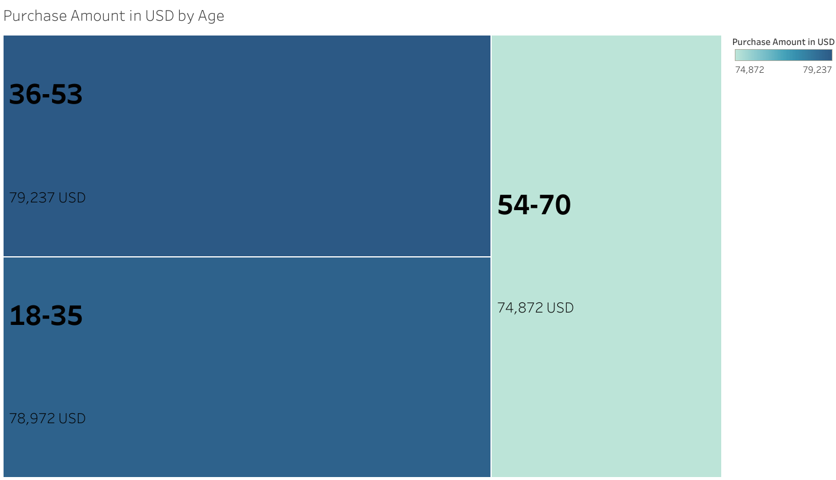

Age and purchase amount in USD are numerical variables so to give information about these two variables treemap is chosen. Treemap provides a clear understanding about age and purchase amount in USD at a glance. By using the color map and looking at purchasing amount in USD, it can be understood that 36-53 age group spends the most money for fashion while 54-70 age group spends the least money. But can we say that fashion companies should focus on 36-53 age group and ignore others? Obviously, it’s a no when we look at the difference of purchase amount in USD between 36-53 age group and 54-70 age group it’s about 4500 USD and when we look for the count of customers in these age groups by using the tooltip it can be seen that purchase amount per customer is nearly the same for three of the age groups and it is about 50.7. So, focusing on a specific age group won’t be a wise decision for fashion companies.

- Is there any fashion item that majority of a specific age group purchase it?

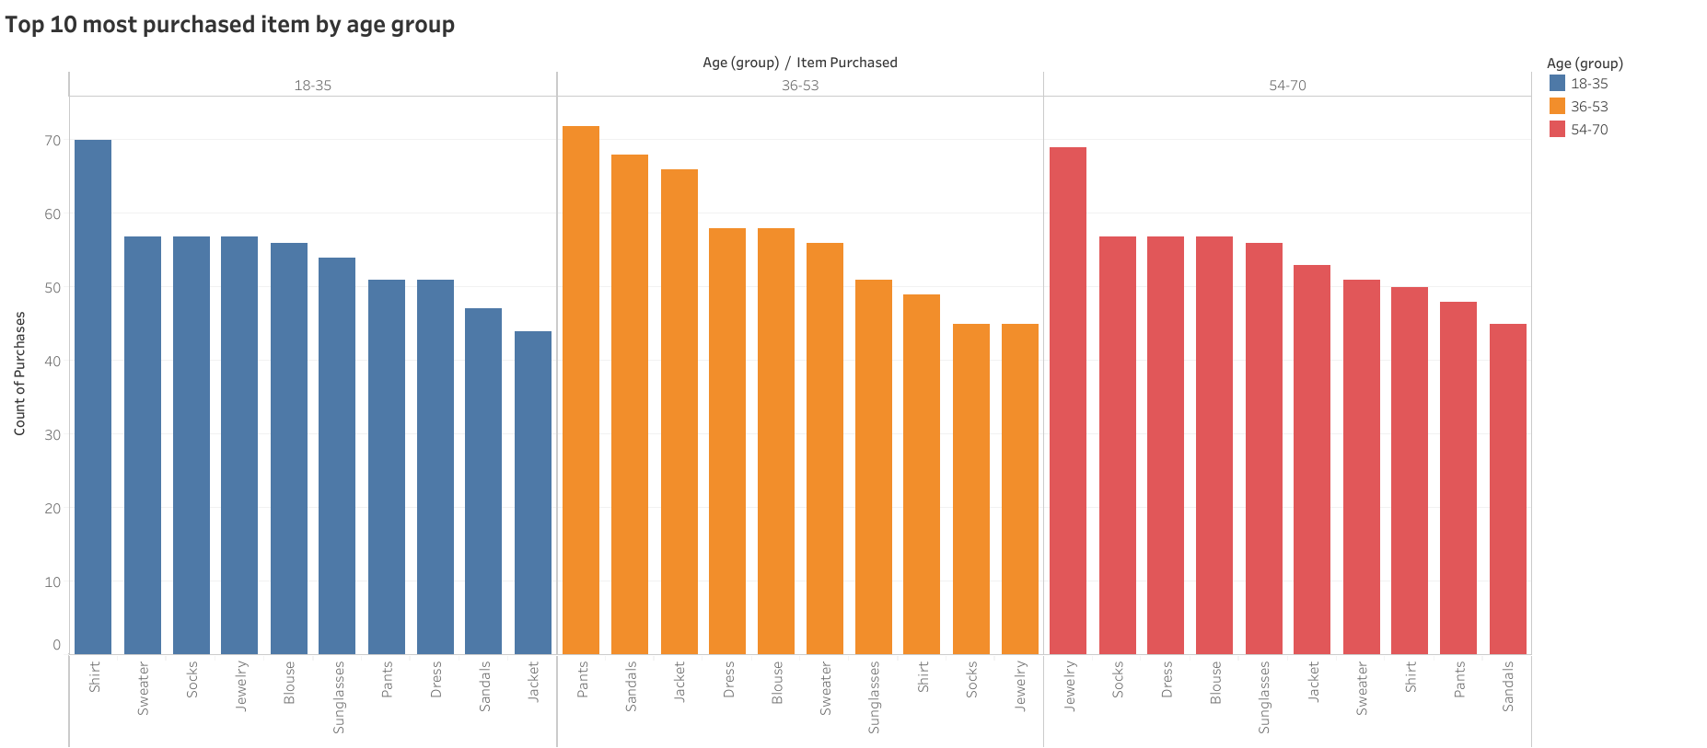

We said that it is not a wise decision to focus on a specific age group for fashion companies. But can they give weight to some fashion items for specific age groups. In this dashboard we can see the top 10 most purchased item by age group. It can be seen that top seller of each age group is different. For instance, count of shirt purchase is 70 for 18-35 age group while count of shirt purchase of other age groups is nearly 50 when we use the tooltip, we can see that purchase amount of shirt in USD is 4519 USD for 18-35 age group, 2744 USD for 36-53 age group and 3069 USD for 54-70 age group. So, 18-35 age group is ahead of others in terms of count of shirt purchases and purchase amount of shirt in USD therefore it would be a wise decision for a fashion company to give weight to designs appealing to the 18-35 age group for shirts in proportion to number of purchases. Similarly, same things can be said that for pants in 36-53 age group and for jewellery in 54-70 age group.

- How does review rating of subscribers differ from review rating of non-subscribers?
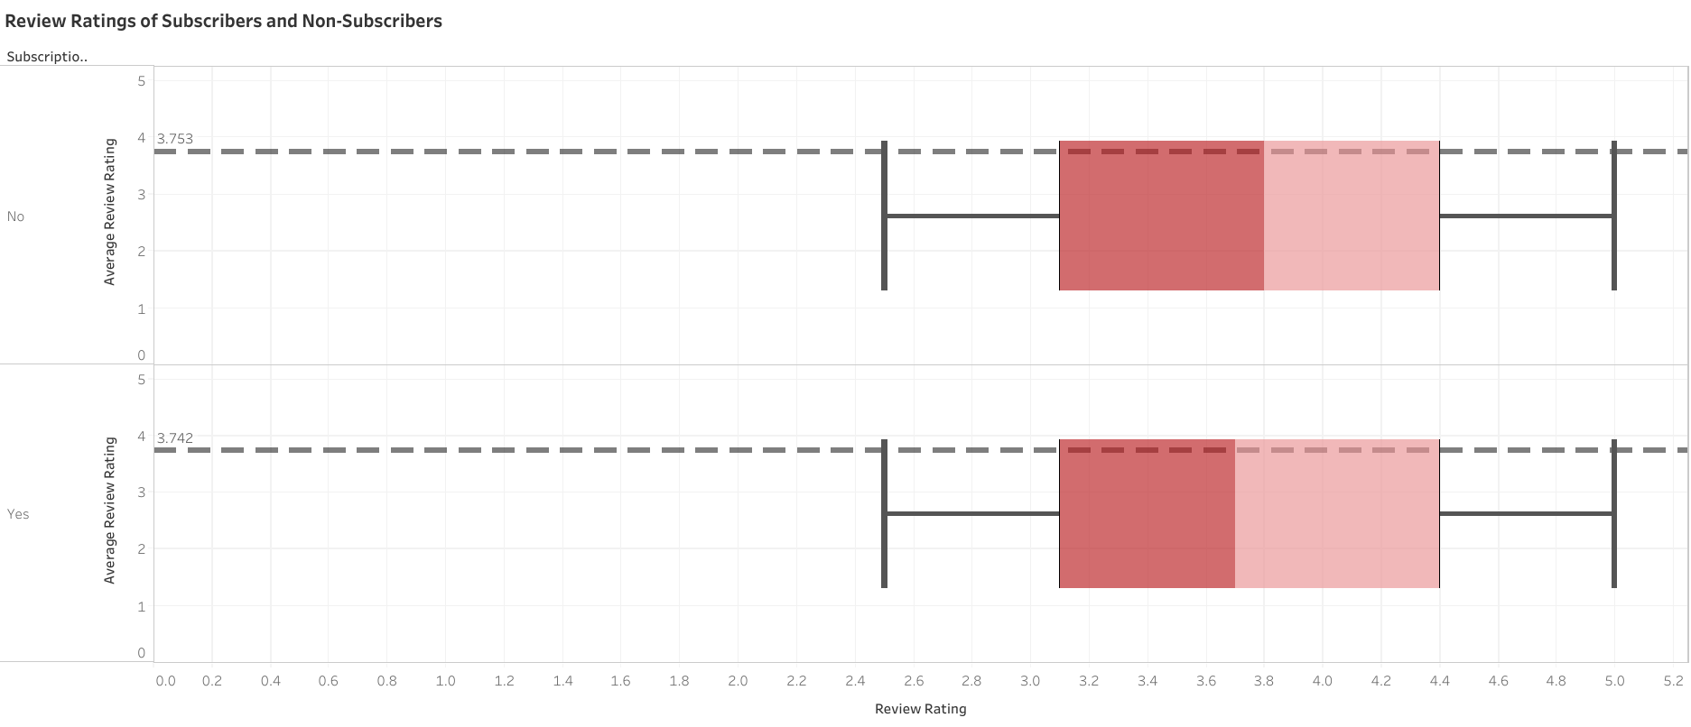
Fashion companies offer subscription privileges for their subscribers but are they enough to satisfy their subscribers and increase their review rating? Being a subscriber or not is a categorical and review rating is a numerical variable. In order to examine these variables a box plot would be helpful. When we look for spread it is clear that they are the same range of ratings are equal for both subscription status. Medians values are nearly the same for both of subscription status median value of non-subscribers is 3.8 so, it can be stated that 50% of the review ratings of non-subscribers are above 3.8. Median value of subscribers is 3.7 so 50% of the review ratings of subscribers are above 3.7. Average rating of non-subscribers is even higher than average rating of subscribers. To conclude, it seems that some of the subscribers are not satisfied. So, fashion companies should offer more privileges to their subscribers in order to prevent them from cancelling their subscription and at the same time they can increase their review rating.

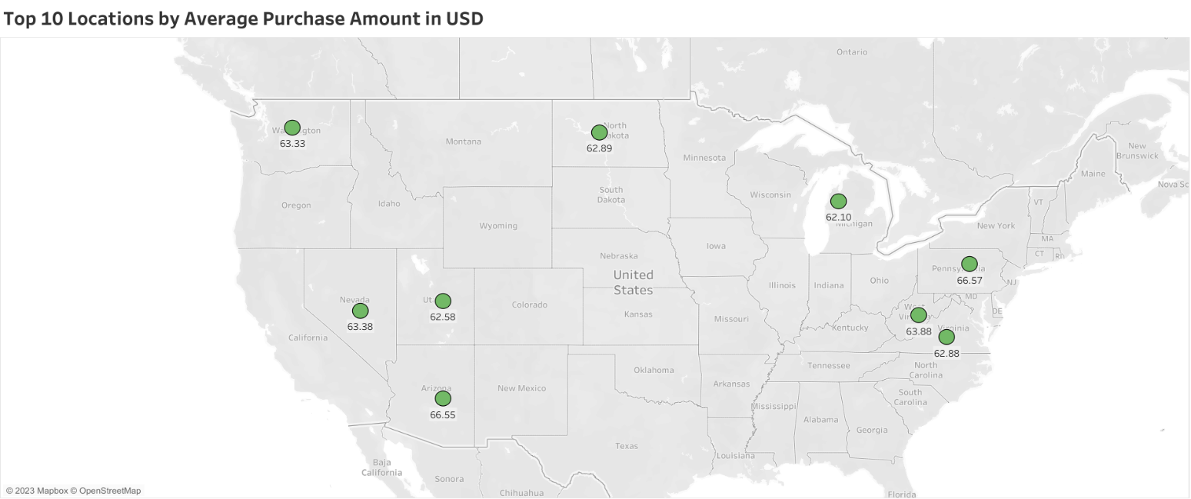
- In which locations average purchase amount in USD is higher than others?
To answer this question a map would be helpful so a map of United States which includes states of the country is used and, in this map, we can see the top 10 states by average purchase amount in USD. After learning the states that has the highest purchase amount in USD from this map by using this information, fashion companies can analyze their number of stores and stock status in these states so they can increase their number of stores or stocks in order to increase their income in these states. This map will make more sense after the next question is answered.

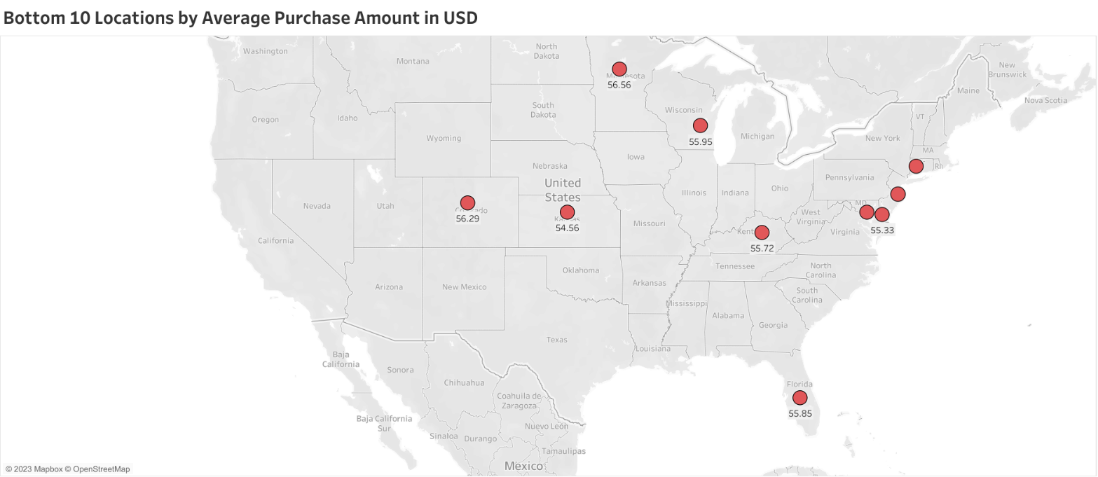
- In which locations average purchase amount in USD is lower than others?

To answer this question the same map with previous question is used a map of United States which includes states of the country. In this map bottom 10 states by average purchase amount in USD can be seen. After learning the states that has the lowest average purchase amount in USD from this map by using this information, fashion companies can analyze their number of stores and stocks in these states in order to make a decision about whether the number of stores is not enough or it is more than enough so that they can close some stores in order to save money or whether they have enough stocks in these states or not.

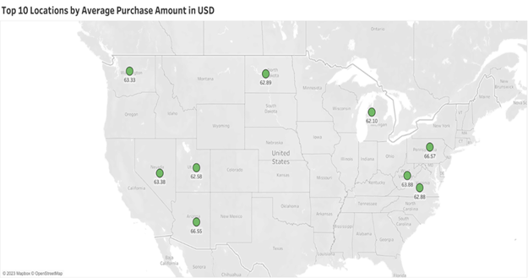
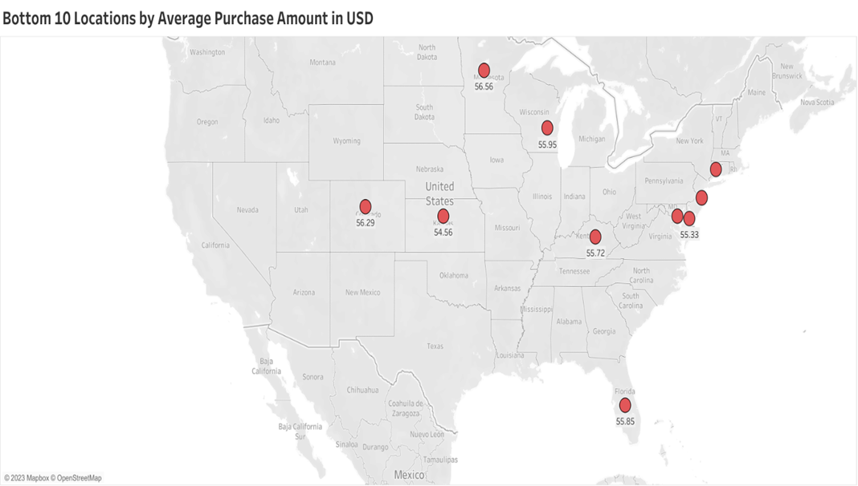

When we examine these two maps together it can be seen that some states which has lower average purchase amount in USD such as Delaware, New Jersey, Connecticut, and Maryland are located close to the states that has higher average purchase amount in USD such as Pennsylvania, Virginia, and West Virginia. This situation also replies to other states for example, Minnesota and Wisconsin are two states that has lower average purchase amount in USD, and they are located between North Dakota and Michigan these states are in the top 10 locations which has the higher average purchase amount in USD list. So, this can mean that people may be going to cheaper states to shop, or it would be about population in these states only to understand that fashion companies should examine in these situations and if it is needed, they should review their price policies in needed states.
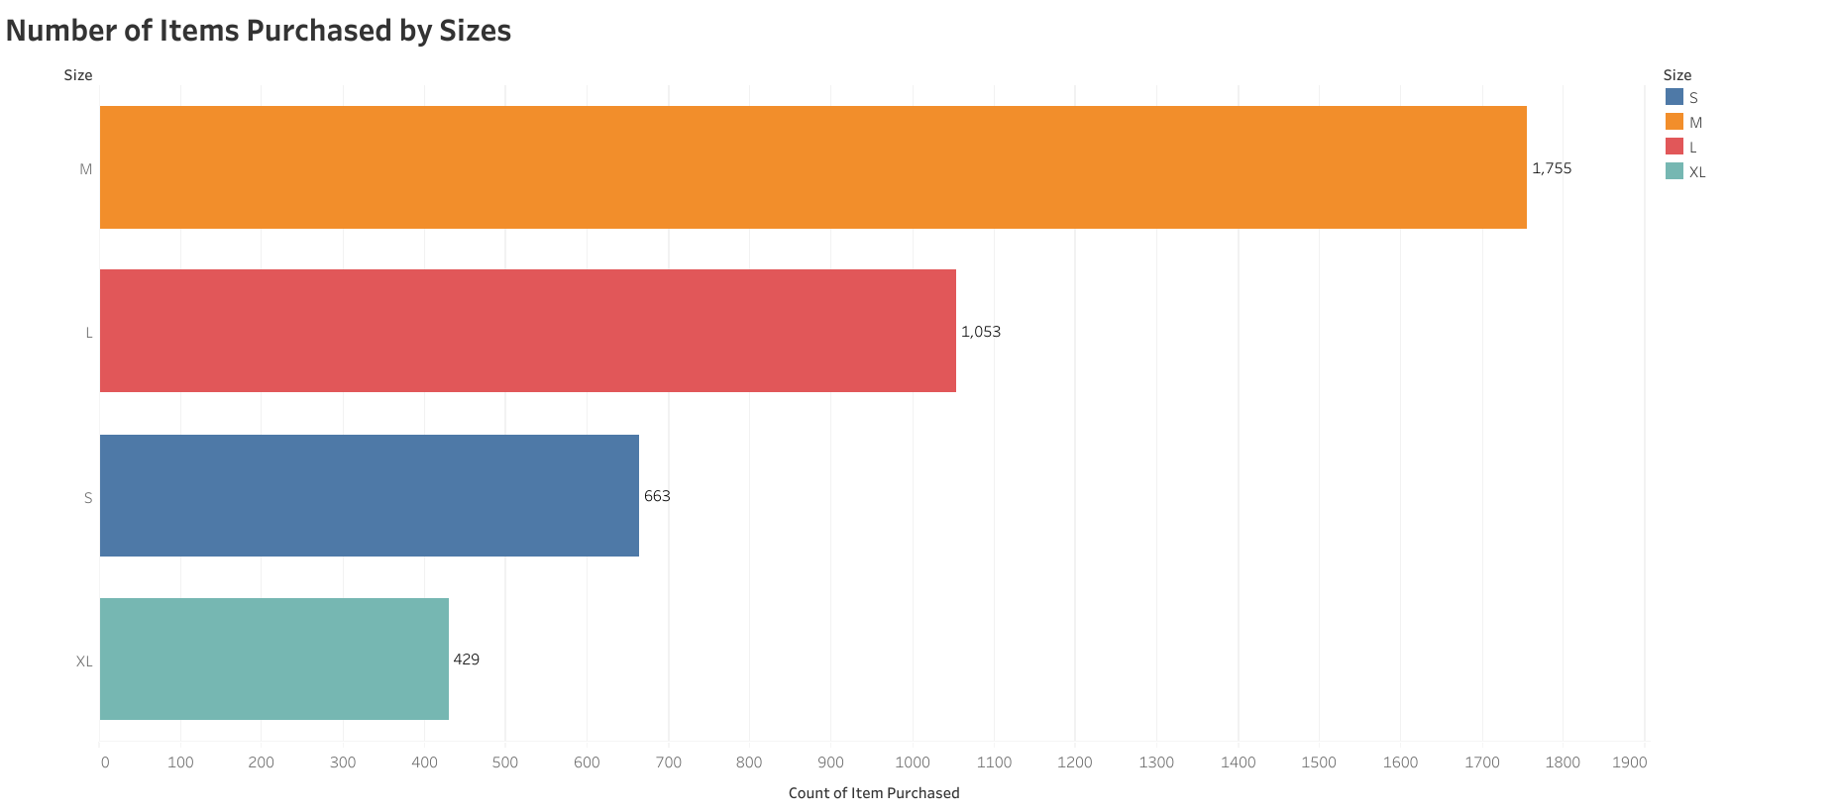
- How does number of items purchased differ by size?

Bar graph is an appropriate method for examining how number of items purchased differs by size. In this bar graph it can be understood that M is the most common size by 1755 while XL is the least common size by 429. By using this graph with the type of the purchased item filter, fashion companies can decide which size they should give weight to while they are producing a specific fashion item. In this way, fashion companies can lower the number of remaining products because they won’t produce same amount of t-shirt, for example, for M and XL sizes.

- How does count of purchases of a specific item differs by season?

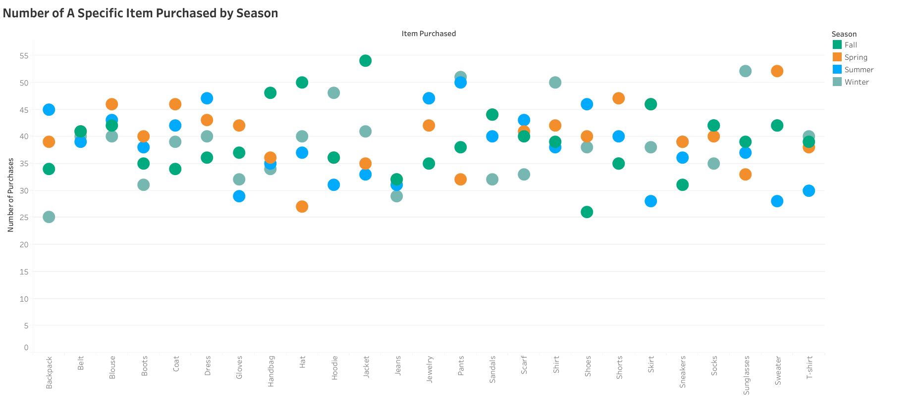
Number of purchases is numerical and item that is purchased is categorical so dot plot can be used to answer this question. Different color of dots represents different seasons, so it is possible to know which season is represented by a specific dot without using the tooltip. By using filters, it is possible to examine seasons one by one so fashion companies can decide which items should they produce on a specific season. It is also possible to view items one by one with item filter so fashion companies can use this plot when they have remaining items. In this way, they can make some discounts on the season that a specific item is sells not that much.

CONCLUSION

To sum up, in this project 7 questions were asked to help fashion brands on how they can increase their income. It is understood that focusing on a specific age group is not a wise decision instead focusing on most purchased items by age groups is more sensible. We saw that average rating of subscribers are a bit lower than average rating of non-subscribers and it is stated that fashion companies should focus on this situation because it seems interesting. Two maps about average purchase amount in USD were compared and it is concluded that there can be different reasons for the difference between 2 maps and it is vital for a fashion brand to investigate these reasons. Then, most purchased sizes were investigated, and it is remarked that fashion brands should give attention to this graph when they are producing an item. Finally, number of items purchased by season was the focus and it is stated that this dot plot can be useful for fashion brands to decide what to produce in a specific season and it can also help on making discounts to sell remaining items.

Tableau Link:
https://public.tableau.com/views/GuideforFashionBrands/GuideforFashionBrands?:language=en-US&publish=yes&:display_count=n&:origin=viz_share_link

